Contributor: David Fernando Cortés Saavedra

**Uruguayan Constructivism**

Uruguayan Constructivism was a dynamic artistic and cultural force embodied by the *Asociación de Arte Constructivo* (1934-1942) (AAC) and later on by the *Taller Torres-García* (1942-1965 ) (TTG) with enormous local and national resonance, setting the bases for the growth of concrete art in South-America during the 1950s as well as for the development of constructivist mural painting and conceptual art in the continent. The AAC group was founded by Joaquín Torres-García, and included Carmelo de Arzadun, Julián Álvares Márques, Inés Caprario, Maria Sara Gumendez, Jorge Nieto, Héctor Ragni, Lila Rivas, Carmelo Rivello, Augusto Torres, Nicolas Urta, Rosa Acle, Alberto Soriano and María Cañizas and developed an art based on geometry, frontality and the use of Indo-American Pictograms directly influenced by **Torres García**´s aesthetic doctrine of Universalismo Constructivo. Coinciding with a loss of momentum in the multi-artistic activities of the ACC already visible from 1939, the association’s painting workshop morphed into the TTG, which was officially founded on October 14, 1942. Its founder members where young artists of a new generation, among them Francisco Matta, Julio Alpuy, Gonzalo Fonseca, Zoma Baitler, Edgardo Ribeiro, Alceu Robeiro, Héctor Ragni, Luis Gentieu, Daniel de los Santos, Luis San Vicente and Torres-García’s sons Horacio and Augusto Torres.

After a 43 years absence from his country, Joaquín Torres-García arrived to Montevideo in 1934 with the intention of founding a *School of Arts of Uruguay*. On December 25, 1934 his project materialized with the first exhibition of the AAC, which presented a third option on the national panorama of the arts dominated until then by social realism and academic naturalism. The ACC published the Magazine *Circulo y Cuadrado* between 1936 and 1943, which acted as a bridge between European Modernism and Uruguayan geometric and constructive art while also being a platform for the exposure of the association’s ideas on ancient Indo-American art and its iconography.

As AAC lost moment, TTG came to substitute it and gain prominence in the Uruguayan artistic scene. Between May and July 1944, 21 members of the TTG worked on 35 constructivist mural paintings for the Martirené aisle of the hospital of the Colonia Saint-bois in Montevideo, rendering through bright primary colors the grid system and flat schematic figuration typical of the AAC. This, their most influential work, also marked the active integration of female artists such as Teresa Olascauga, Maria Celia Quela Rovir, María Elena García Brunel, Josefina Canel, Esther Barios and Elsa Andrada into public commissions of such magnitude. Responding to the attacks of the more conservative fractions of Uruguayan criticism, the TTG published *Removedor*, a belligerent magazine destined to the defense of constructive art.

After the death of Torres-García the TTG continued functioning until the middle of the 1960s. José Collel and Gonzalo Fonseca recreated lost pre-Colombian ceramics techniques while the latter also made monumental cement sculptures in Mexico and in the United States. Augusto and Horacio Torres executed commissions of furniture and monumental brick murals and succeeded in recreating the texture and quality of stain glass using plastic panels. Further echoes of the aesthetic forwarded by the ACC and TTG can be found in later manifestations of concrete and constructive art in South-America.

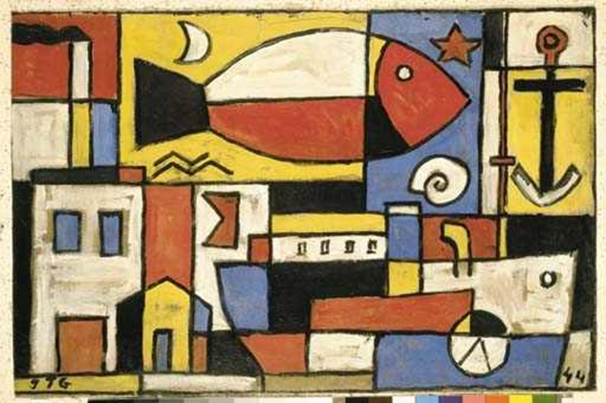

Joaquín Torres-García *Construcción*.(1942. Sketch for the *Martirené aisle* wall painting).

Juan Ramón Menchaca, Montevideo, gift from the artist. Private collection, Buenos Aires.

http://www.mutualart.com/Artwork/Construccion--boceto-para-el-mural-de-St/62935E4FB7DE8547.

**References and further reading:**

Bulanti, María Laura. (2008) *El Taller Torres-García Y Los Murales Del Hospital Saint-Bois: Testimonios Para Su Historia*. Montevideo: Libreria Linardi y Risso.

Peluffo Linari, Gabriel. (1999) *Historia de la Pintura Uruguaya tomo 2.* *Entre Localismo Y Universalismo: Representaciones de La Modernidad (1930 - 1960)*. [versch. Aufl.]. Montevideo: Ed. de la Banda Oriental.

Ramírez, Mari Carmen, and Cecilia Buzio de Torres, ed. (1992) *El Taller Torres-García: The School of the South and Its Legacy*. Austin: Univ. of Texas Pr.

Torres García, Joaquín, Alejandro Diaz, Jimena Perera, and Demian Diaz Torres. (2004) *Universalismo Constructivo: Óleos, Maderas Y Dibujos ; 28 de Julio Al 15 de Diciembre de 2004 ; Museo Torres García*. Montevideo: Museo Torres García.